CS 420

Assignment 1

Name : Lalitha Bhogaraju

WIU id : 915-66-5006

1. Physical address : 98-90-96-B6-1E-EE

Ipv4 : 143.43.209.37

Physical address belong to datalink layer.

Ipv4 address belong to network layer.

The Adapter needs two address. Ipv4 address is for connectivity. The physical address is to locate the address of the system.

2)

1. Yes. Delay does change when packet size changes. When packet size changes the time required to transfer the packet also changes. Packet size is directly propositional to time required.
2. The maximum packet size that can be sent out is 1472 bytes.

3)

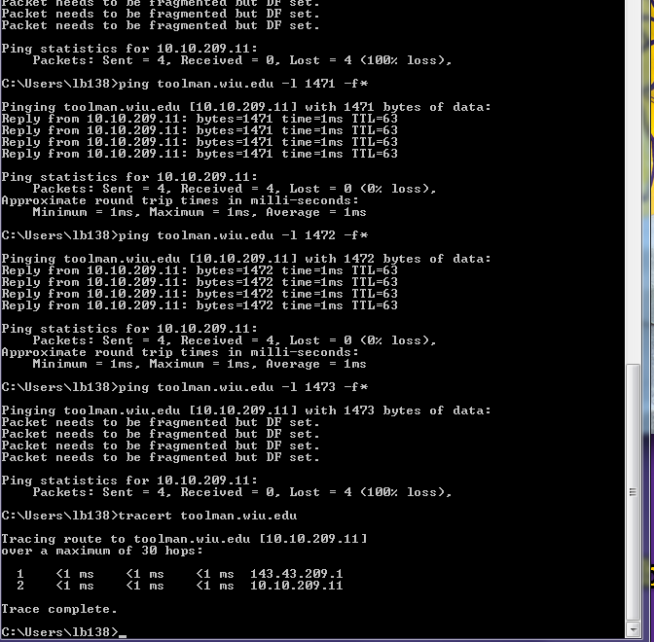

I see two address and also the

toolman address at the same time the maximum number of hops are also displayed.

**Trace Route** :

Tracks the packet from source to destination.

**Tracert** :

* Tracert commend is used to trace the path and time taken of the packet to the destination.

4)

Circuit-switched networks requires point-to-point connections during calls. It is very reliable when compared to Packet.

The Main advantage of TDM over FDM is :

* In TDM each signal uses all of the bandwidth to send a data from source to destination. while for FDM, each signal uses a small portion of the bandwidth and it tranfers bit by bit ruther then the whole data as one.

5)

Transmission Delay :

First link ( 1 Mbps) : 100/1 = 100 Sec

Second link (10 Mbps) : 100/10 = 10 Sec

Third link (5 Mbps) : 100/5 = 20 Sec

Total time taken : 100+10+20 = 130 Sec.

6)

a.) A circuit-switched network application involves long sessions with smooth bandwidth . Since the transmission rate is known as Bandwidth can be reserved for each application session with no waste. we do not need to worry much about the overhead costs and tearing down a circuit connection.

b).The network needs no congestion control mechanism which is occurring of two or more actions at the same time .All the applications transmit over one network link at the same time. Each link offers s bandwidth to handle the applications.

7) Converting 40 TB into MB : 40*1000*1000 = 4 * 106

Converting 100 Mbps into MB = 100/8 = 12.5

4 * 106 / 12.5 = 32 * 103

32 * 103 / {86,400 (seconds per day i.e. 24 hours *60mins *60 seconds)} = 37.03

It takes approximately 37 days to send the data in the form of link .So it’s better to send it through FedEx overnight delivery.

8).

a). Transmission delay = File size / network speed

File size =100 Mbit

Network speed =10 Mbps

-🡪 100/10 = 10Sec

Propagation delay of full file = distance / speed

Distance : 2000 m

Speed of light = 2*108

2000 / 2*10 ^8 = 0.00001Sec

TD + PD for one hop = 10.00001Sec

Total time taken = 3 * 10.00001 = 30.00003Sec

b) .

Total number of packets = 10000

Transmission delay for one packet = 10 Kbit / 10 Mbps = 10-4 Mbits / 10 Mbps = 0.001Sec

Transmission delay for 10000 packet at one node = 0.001 * 10000 = 10Sec

Propagation delay of one packet = 0.00001Sec

Packets are transmitted over 3 times over 2 intermediate nodes

PD < TD hence

Total time taken = 3*TD + PD = 3 * 10 + 0.00001 = 30.00001 Sec